NHS COVID 19 App – Business Toolkit

NHS COVID 19 App Communications Toolkit for businesses September 2020

Dear Business Owners and Managers

The NHS COVID 19 App will be launched on 24 September. This toolkit explains about the NHS COVID 19 App functionality and what part businesses have to play in supporting the App.

We’re asking Surrey businesses to get on board and support the NHS COVID 19 App to help keep Surrey open for business and to protect our community.

Some types of venues will soon be legally required to display a NHS COVID 19 App QR poster ready for the 24 September these are:-

- Hospitality – bars, restaurants, hotels, cafes
- Tourism and Leisure – museums, galleries, gyms, leisure centres
- Local authority buildings
- Places of worship
- Close contact services
- Where an event is taking place in a physical location

ABOUT THE APP

The app functionality does a number of things. https://covid19.nhs.uk/what-the-app-does.html

It will:
- support traditional test and trace methods
- inform the public of rising rates in their postcode area
- alert them if they’ve been in contact with someone who has tested positive (even if they don’t know them
- provide a ‘checking in’ function based on QR codes displayed in venues and public spaces
- allow people to check their symptoms, and book a test if they need one

WHERE DO BUSINESSES COME IN ?

Venues, public buildings, will need to display a QR code poster at the entrance to their buildings that people who have downloaded the NHS COVID 19 App can scan. As a location checker, acting as a digital diary of locations visited.

This way people who have tested positive and have checked into certain locations will trigger an alert to those other people who have been in that same location. The actual venue that triggered the alert will not be named.

This kit provides information about how to download and display a QR poster in your venue. Including some suggested social media assets for businesses to let residents know that businesses are playing their part by having their QR code posters ready.

https://www.gov.uk/government/news/businesses-urged-to-prepare-for-nhs-covid-19-app

https://www.gov.uk/create-coronavirus-qr-poster (this is the link for businesses to create their QR code)

Head to the following YouTube pages to watch an introduction to the QR code process for businesses https://www.youtube.com/watch?v=5oJtkzP8zio& and for an introduction to the new app https://www.youtube.com/watch?v=fp0kHcr_Pi4&feature=youtu.be.

- Support your community let residents know you’re ready for them

BUSINESS SOCIAL MEDIA ASSETS – FACEBOOK, TWITTER, LINKED IN

Here are some social media assets once your QR poster is ready to scan to let your customers know you’re ready for them. This uses the creative approach that is being used across Surrey to encourage residents to download the app. Below are some suggested social media straplines.

FACEBOOK 1080X1080

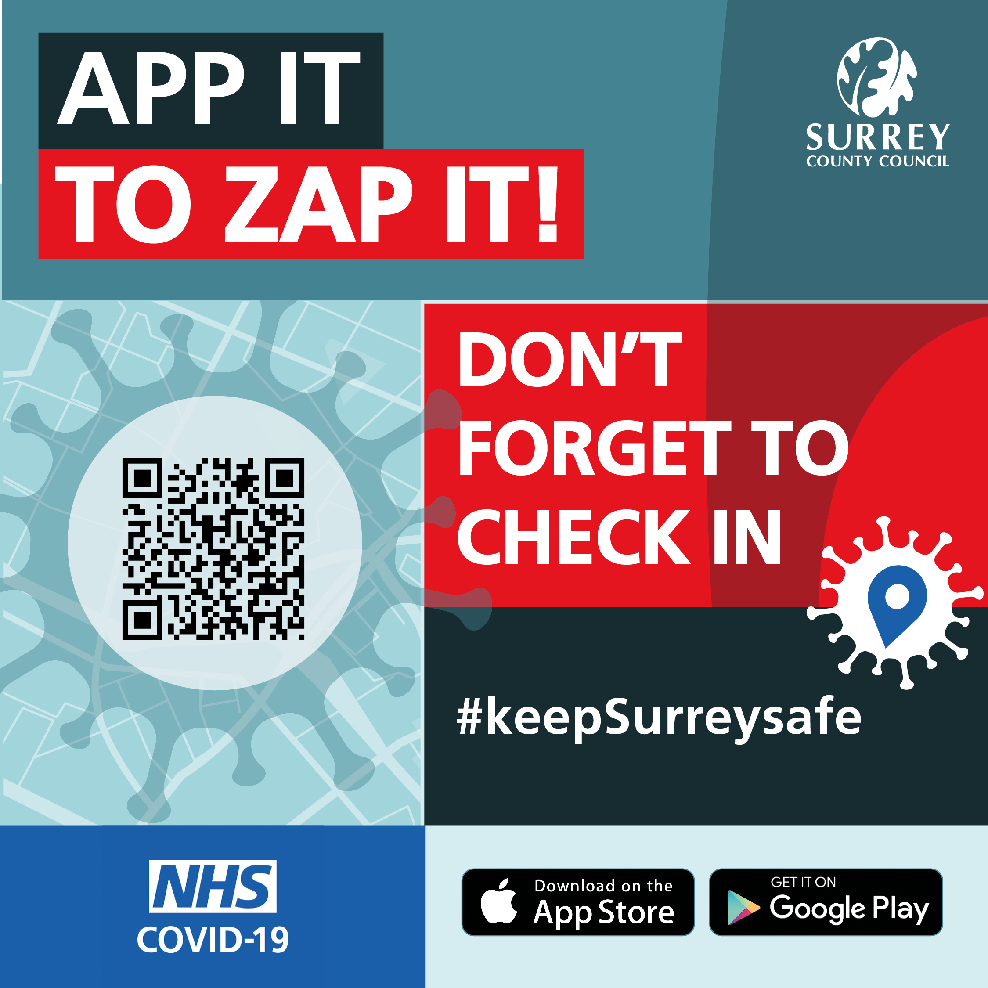

TWITTER 1200X675

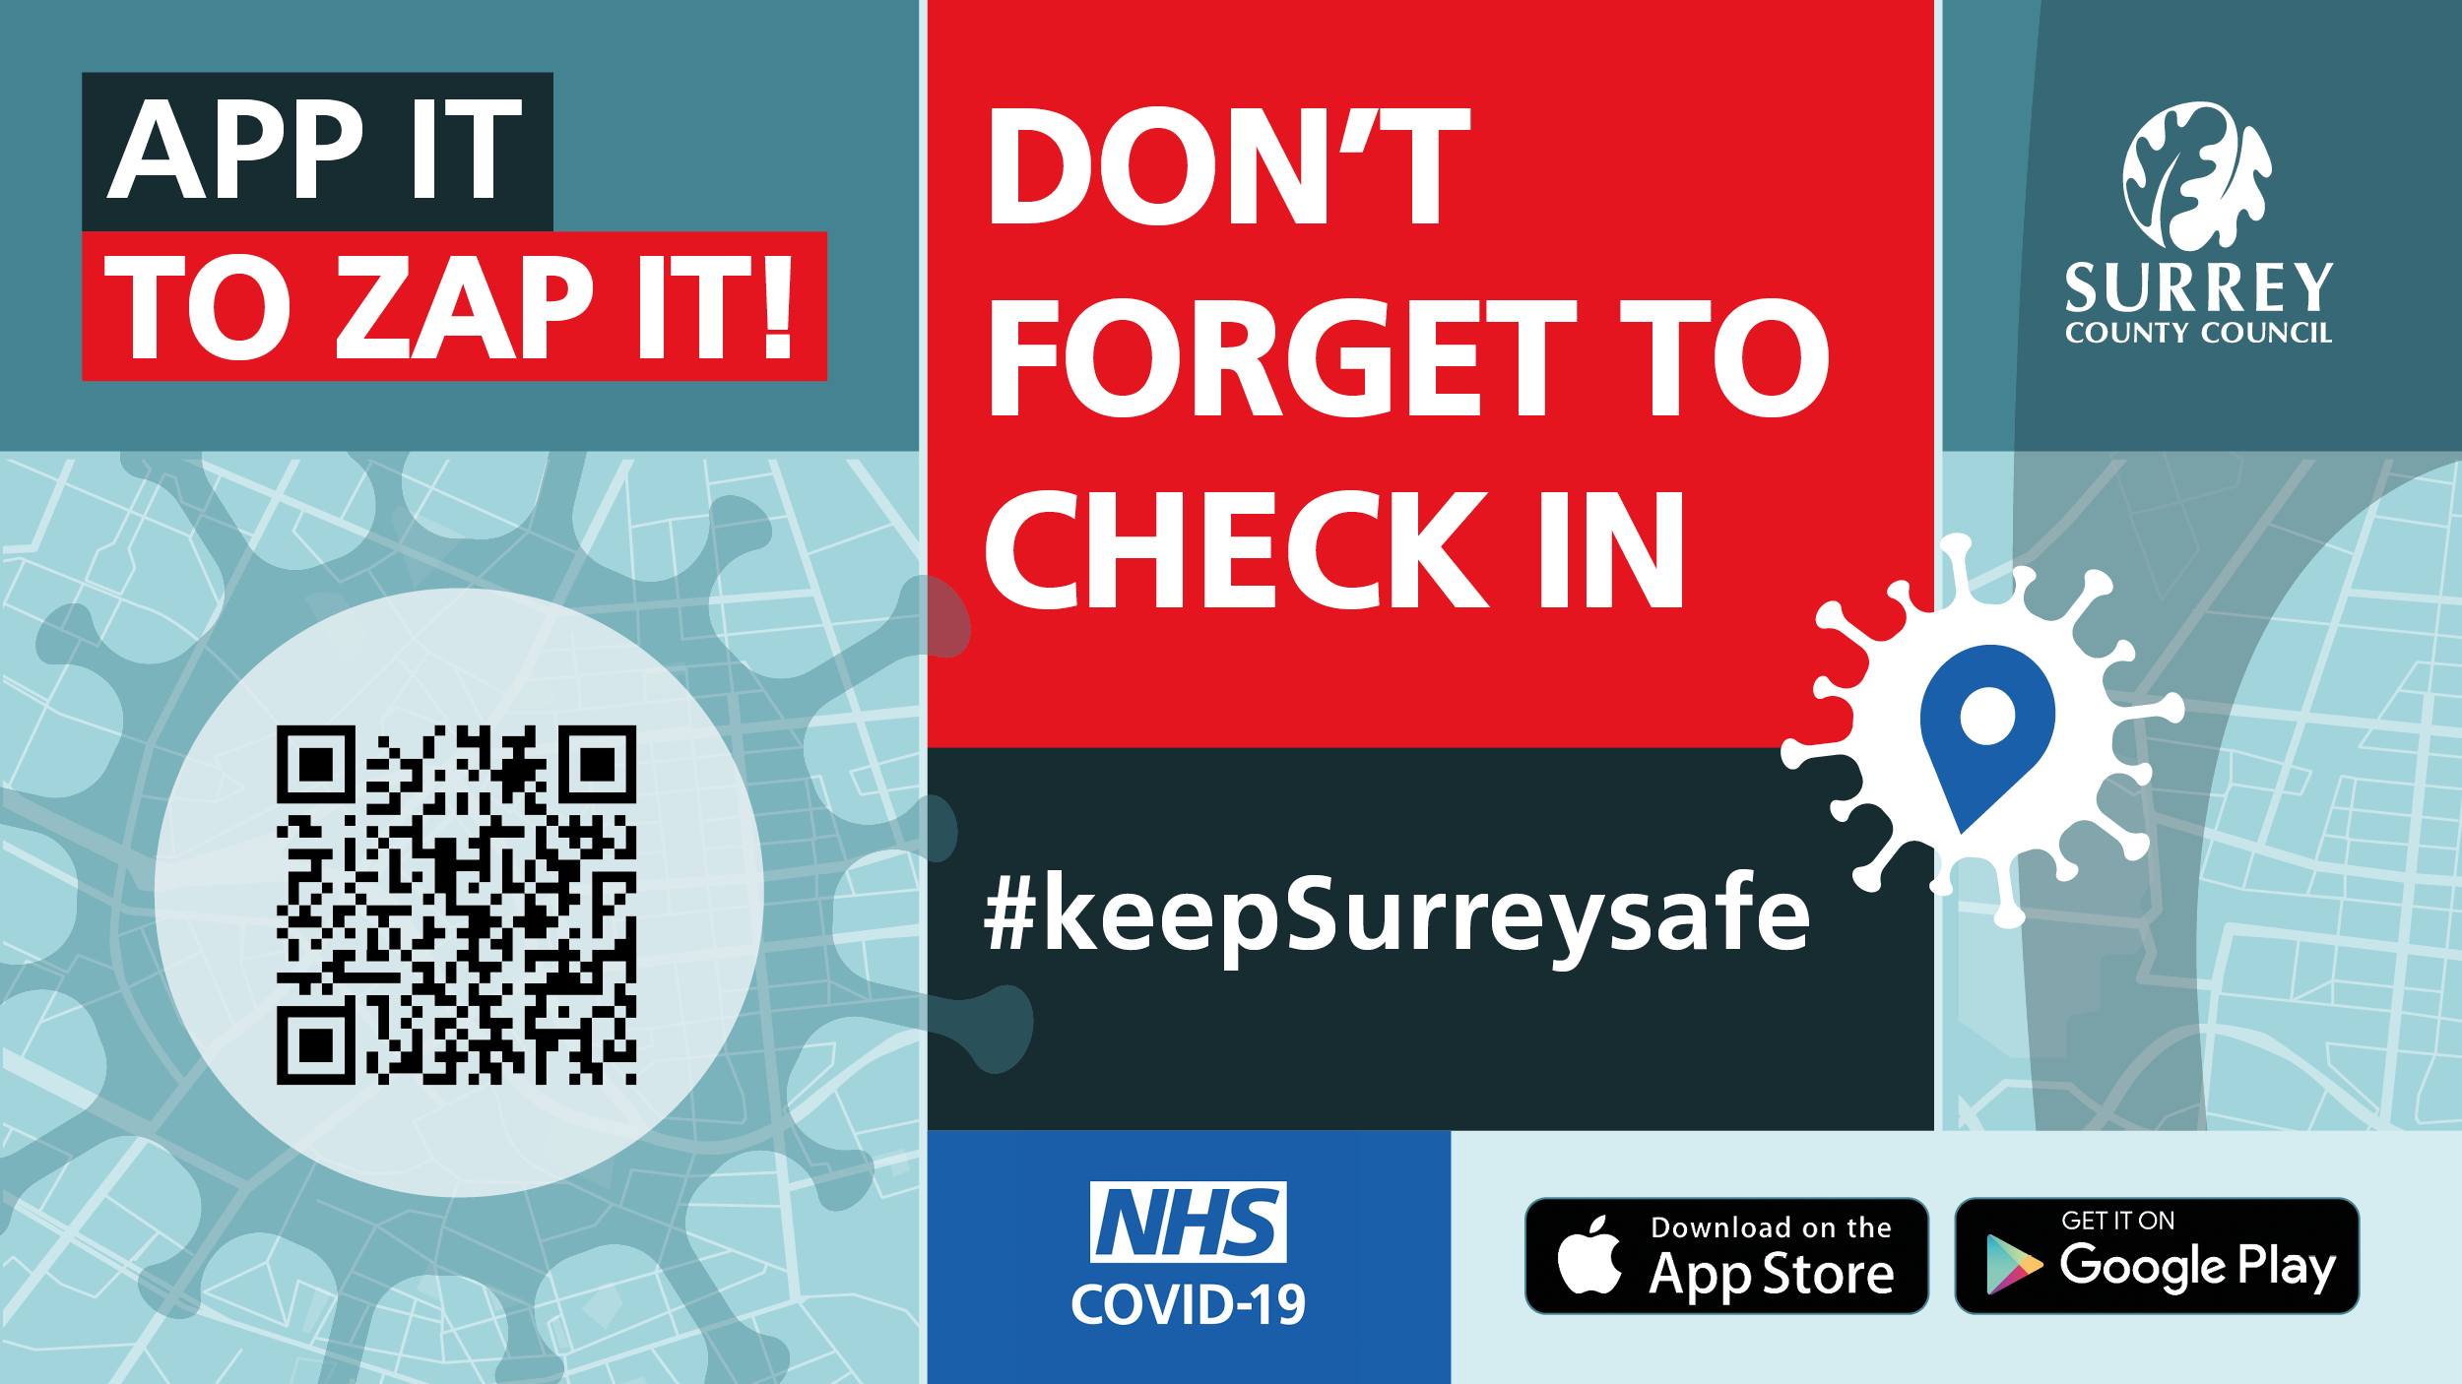

LINKED IN

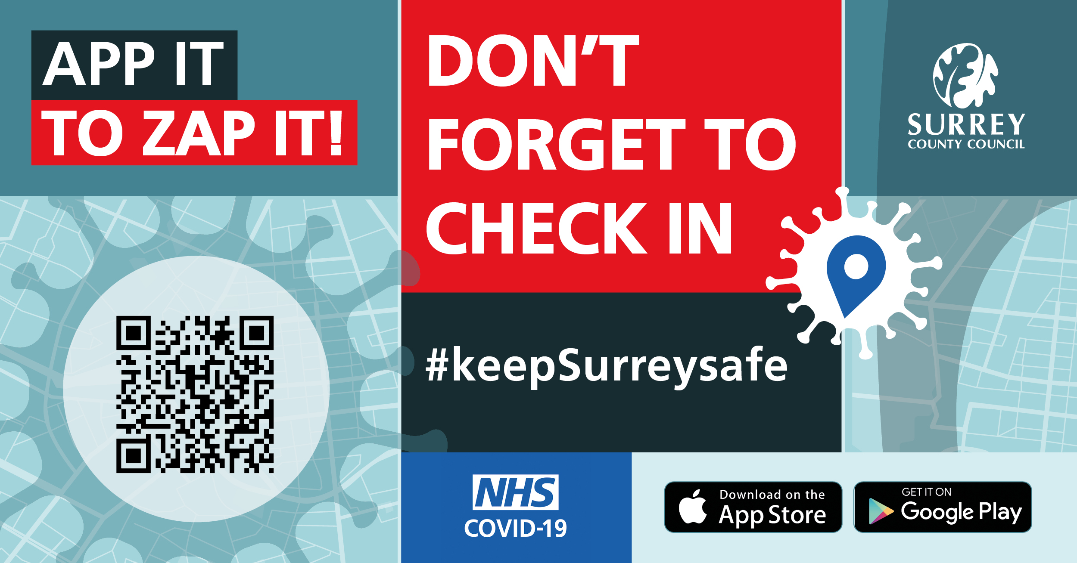

- We’re supporting the NHS COVID 19 App – we’re playing our part to #KeepSurreySafe our QR code is displayed. Information about the App here https://covid19.nhs.uk/what-the-app-does.html

- Don’t forget to check in when you visit us our QR code is ready for your NHS COVID 19 App #KeepSurreySafe. Information about the App here https://covid19.nhs.uk/what-the-app-does.html

- Tap into us with NHS COVID 19 App – our QR code is ready and waiting #KeepSurreySafe Information about the App here https://covid19.nhs.uk/what-the-app-does.html

- Our QR code is waiting for you to visit – come and tap in with the NHS COVID 19 App #KeepSurreySafe. Information about the App here https://covid19.nhs.uk/what-the-app-does.html

